Steps to Create and Configure a Local Agent - AccelQ

**Step 1:**

Click on Resources > Local Agent

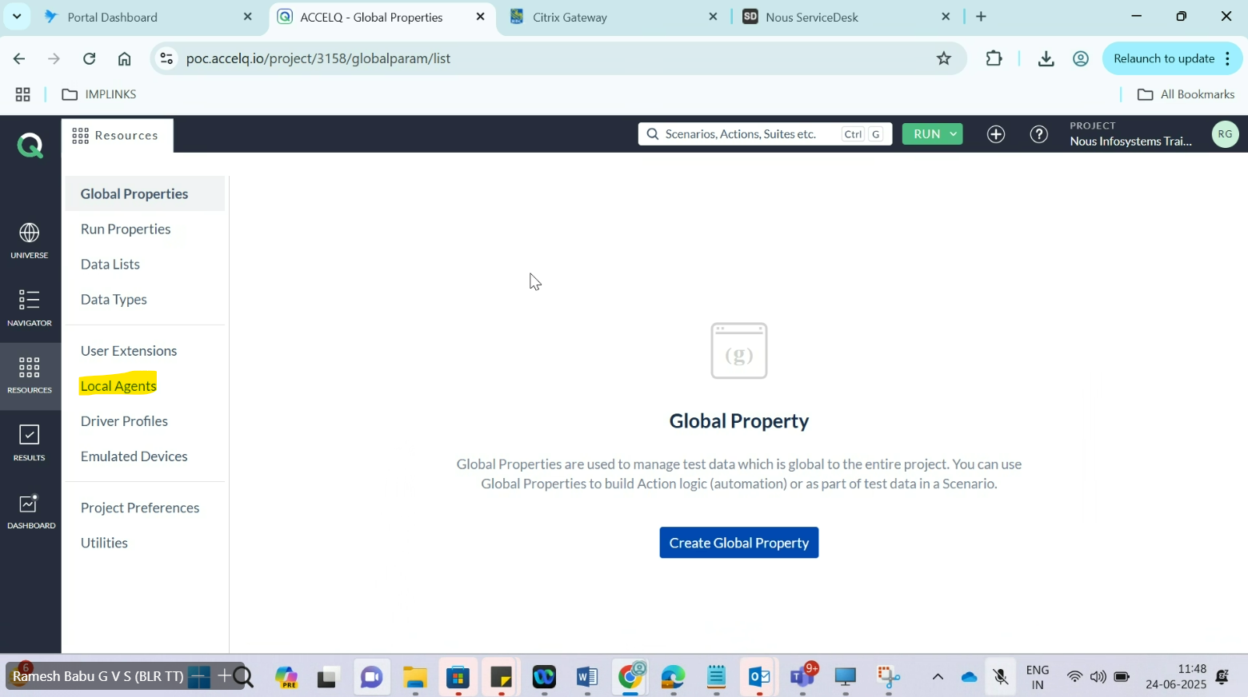

**Setup 2:**

Click Local Agent

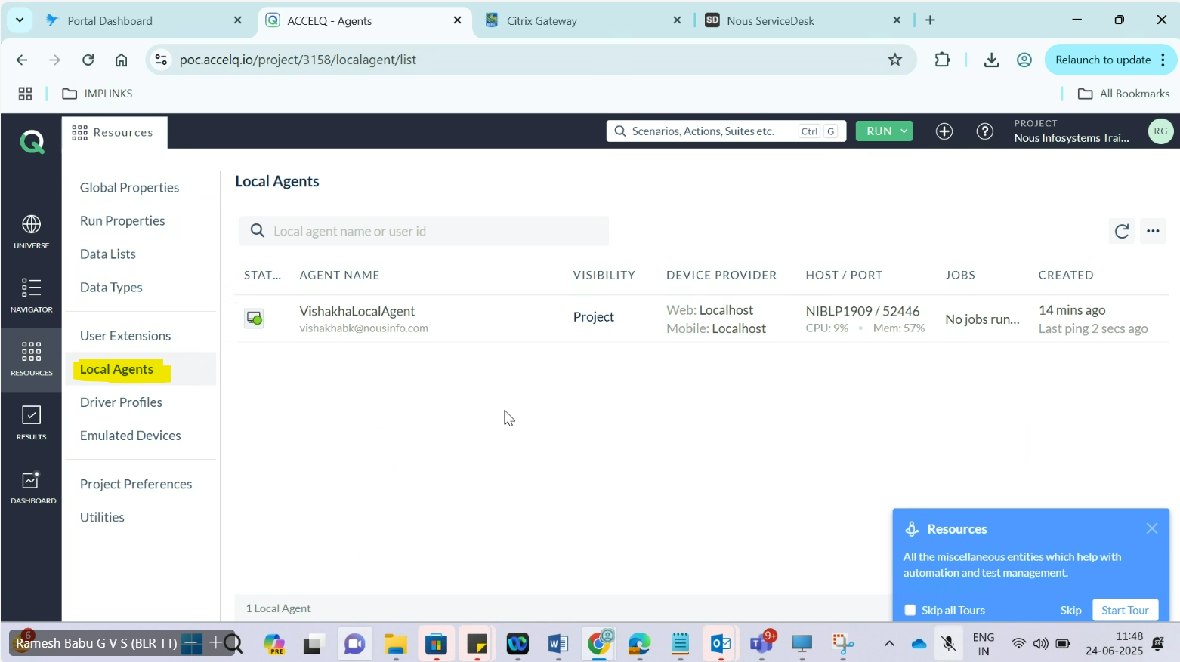

**Step 3:**

Click on Agent Download

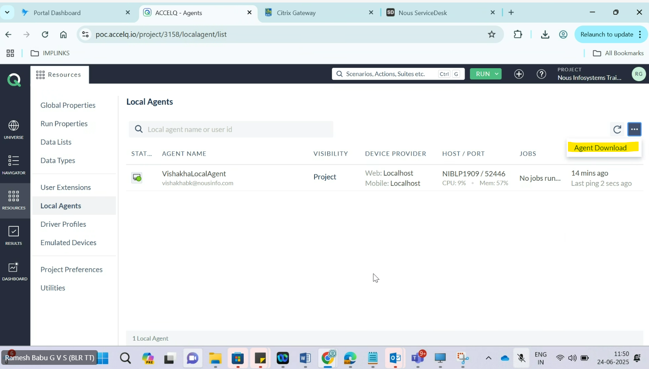

**Step 4:**

Select Installer Wizard > Click Download

Select OS (Windows/Apple/Linux) depending on the machine you have.

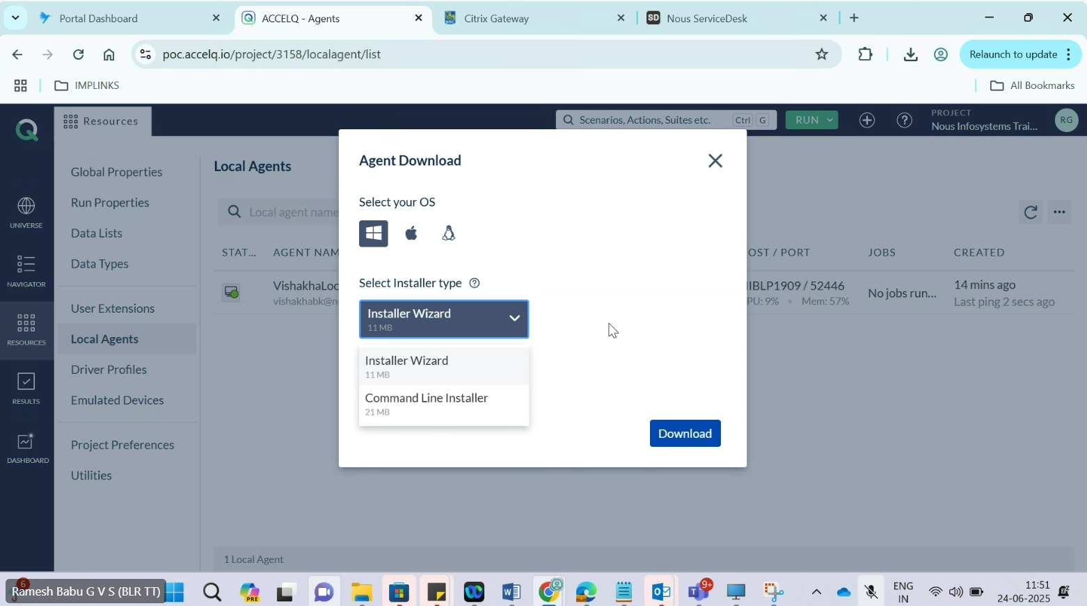

**Step 5:**

It will take time to download the file

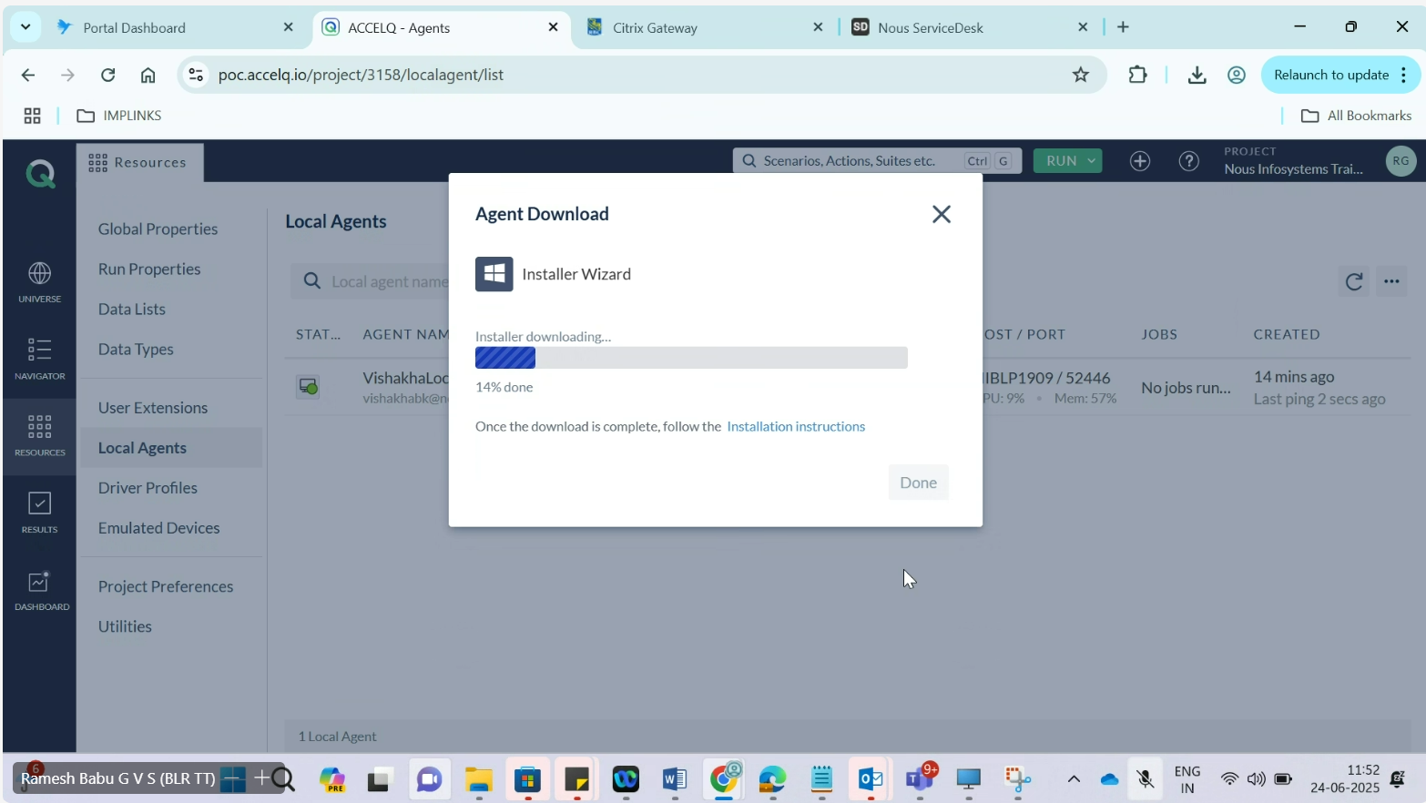

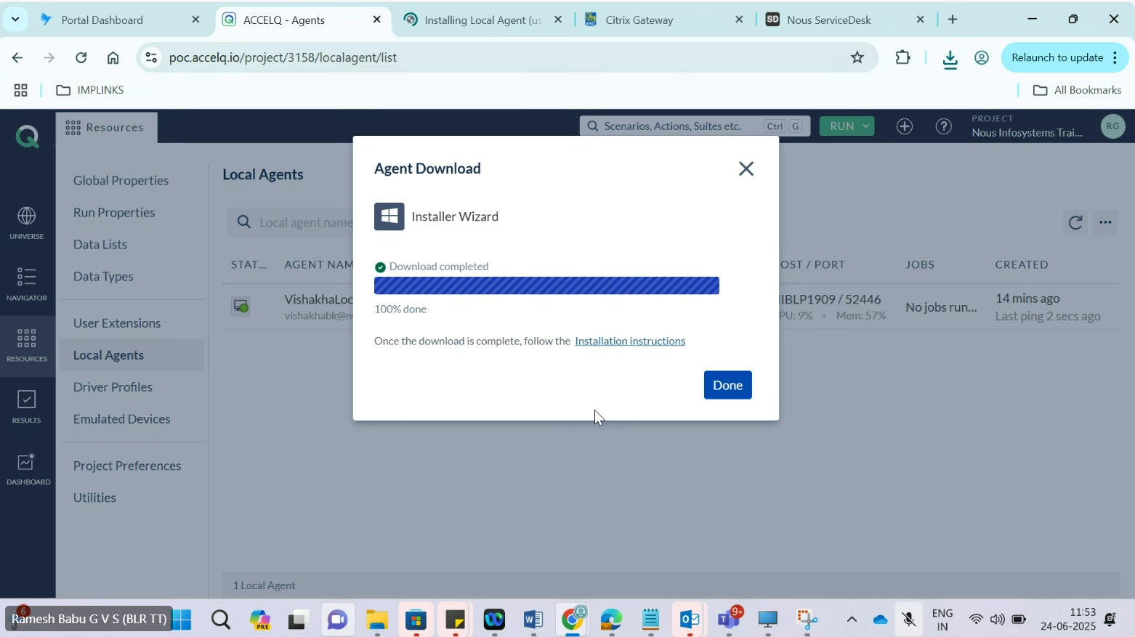

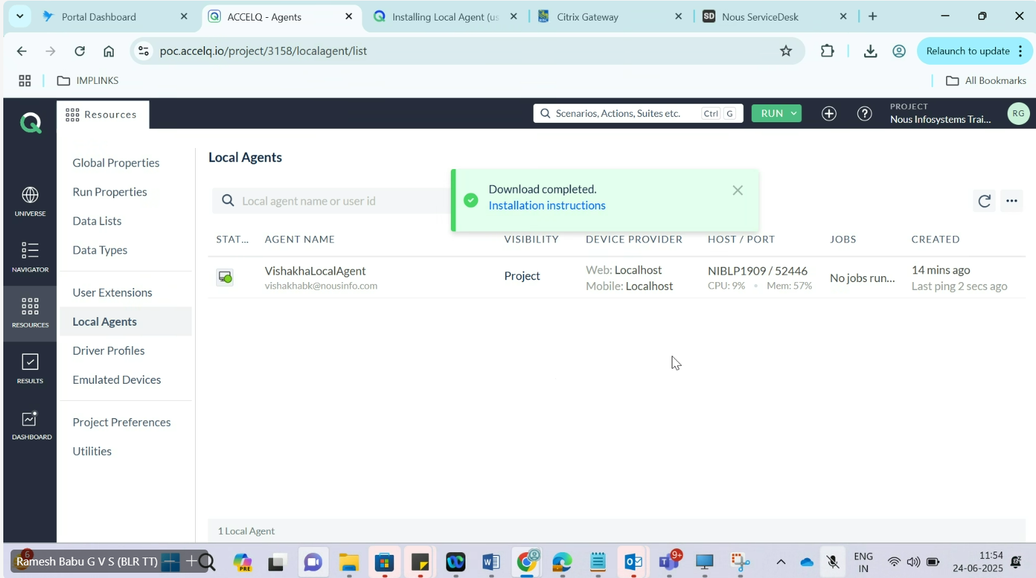

**Step 6:**

Extract Downloaded file and install

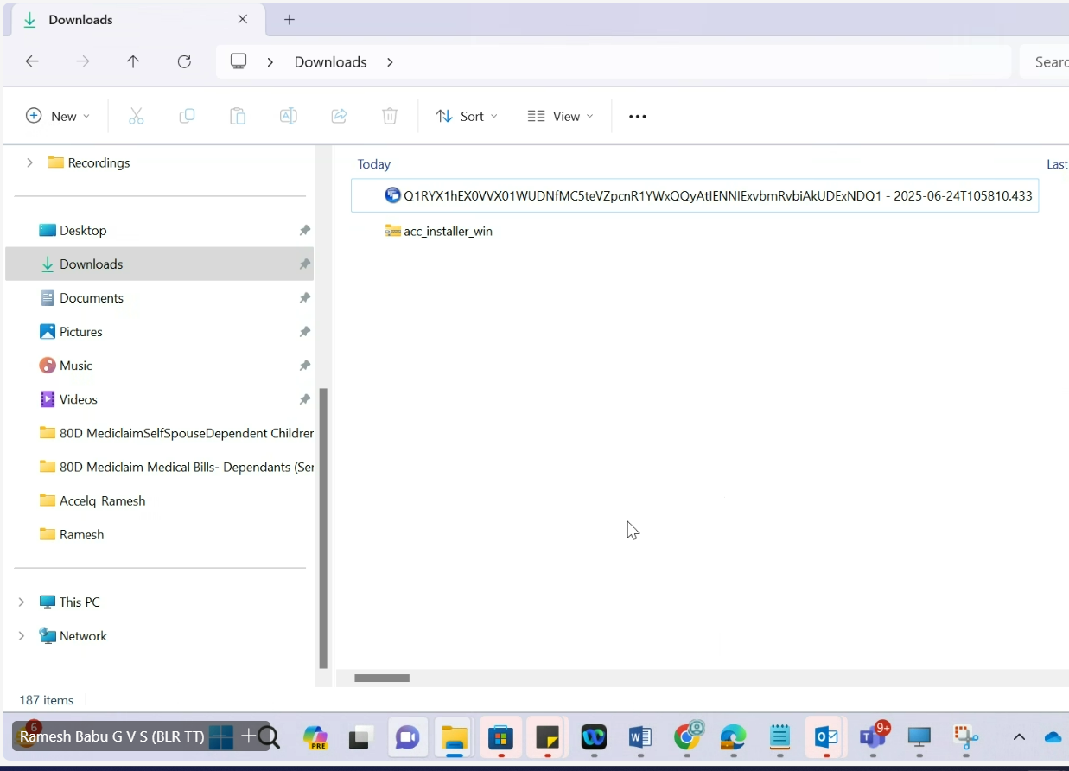

**Step 7:**

Double click on extracted file to install – **ACCELQAgentInstaller** file

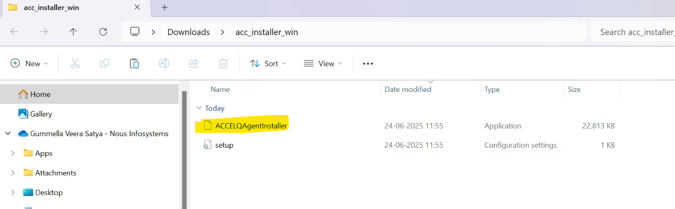

**Step 8:**

Click on “Let’s Go”

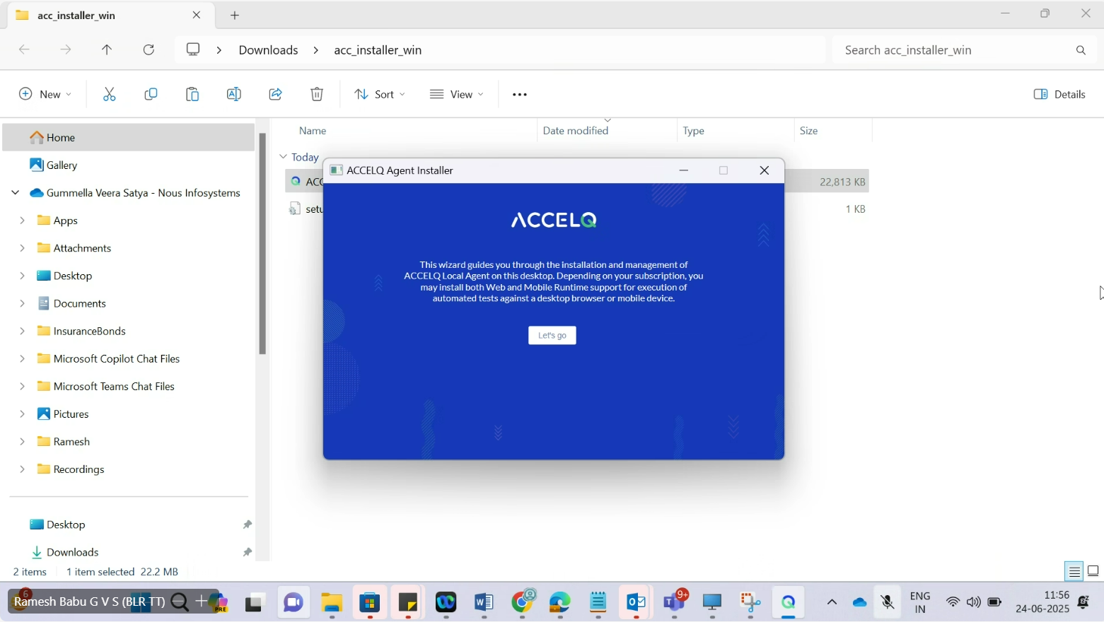

**Step 9:**

Click on “Next”

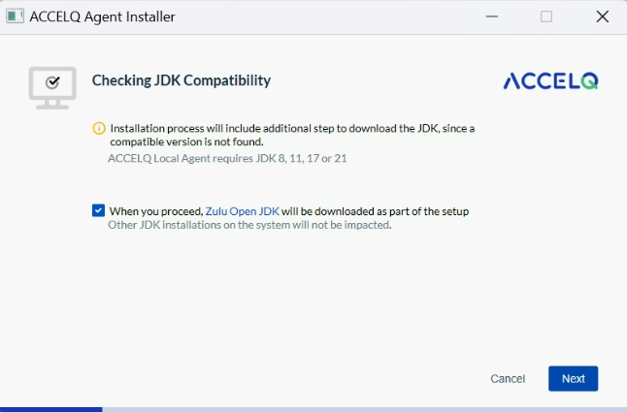

**Step 10:**

Fill all the field values from below screen and Click “Next”

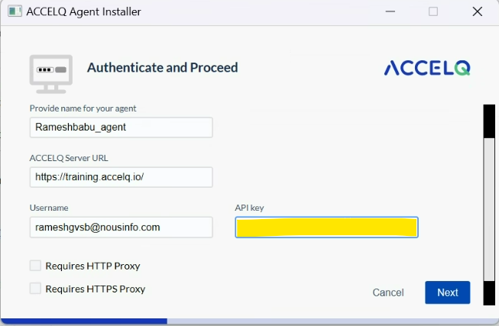

For API Key ->

Profile > Auth Properties > API Key

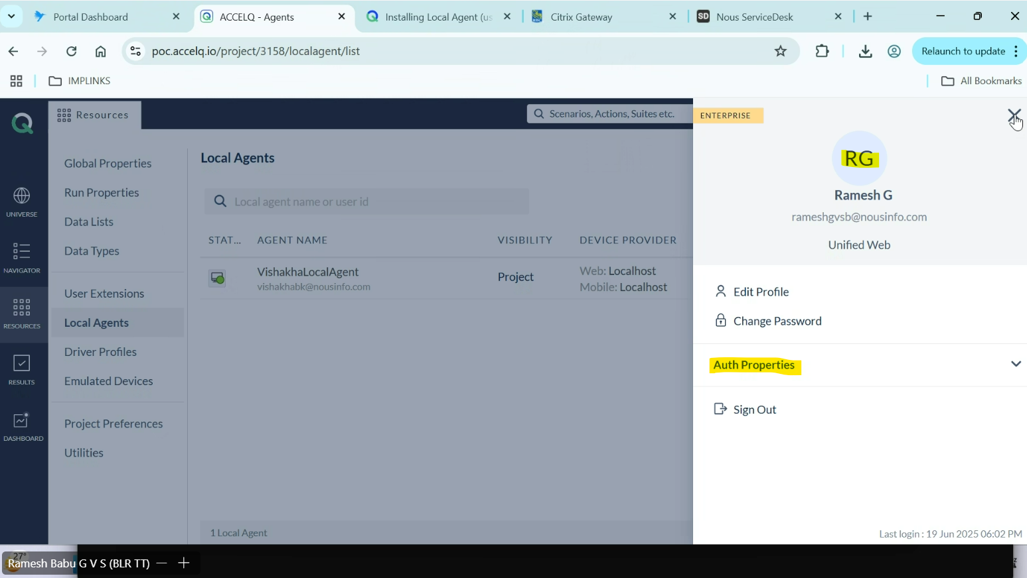

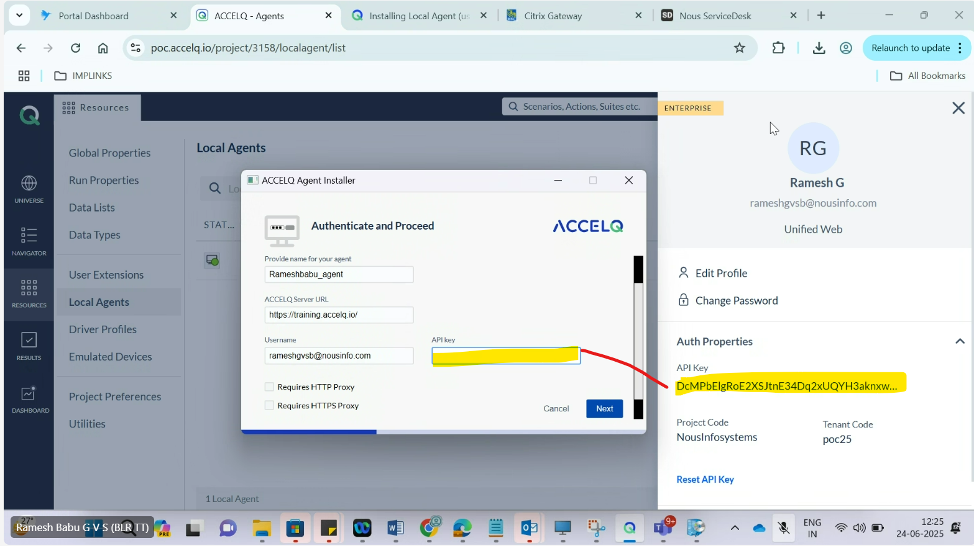

**Step 11:**

Click “Next” on Select Automation Runtime screen

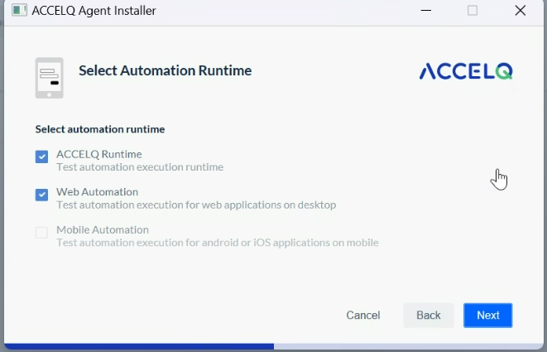

**Step 12:**

Click “Next” on Set Installation Path

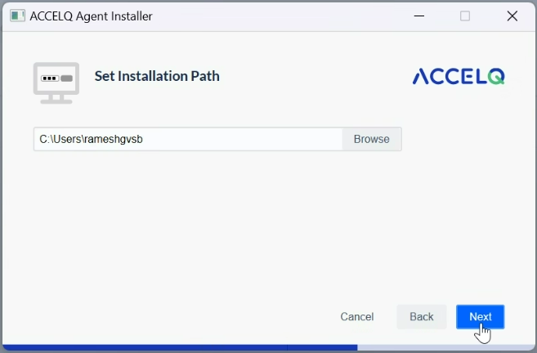

This will take time to install

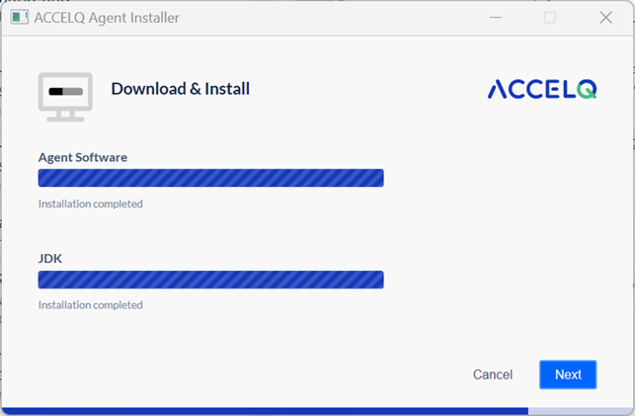

**Step 13:**

Click “Finish” on Summary Screen

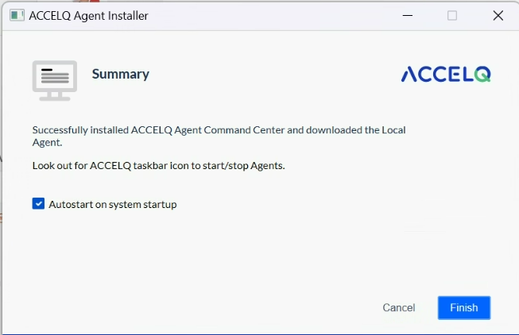

**Step 14:**

Update “Agent Configuration Details” and click on “Save and Start”

Make sure Agent scope is defaulted to "User" only. Do not select Project/Tenant.

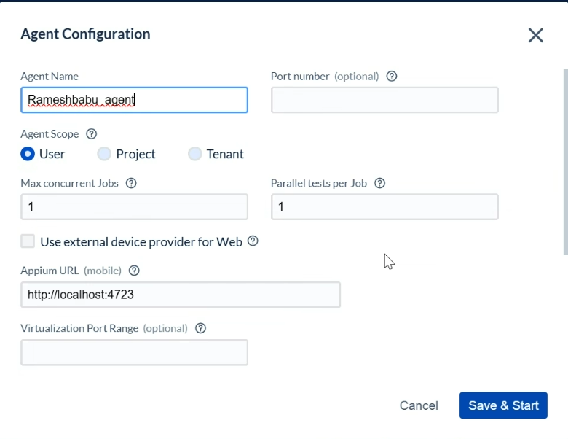

Click on “Allow” on popup

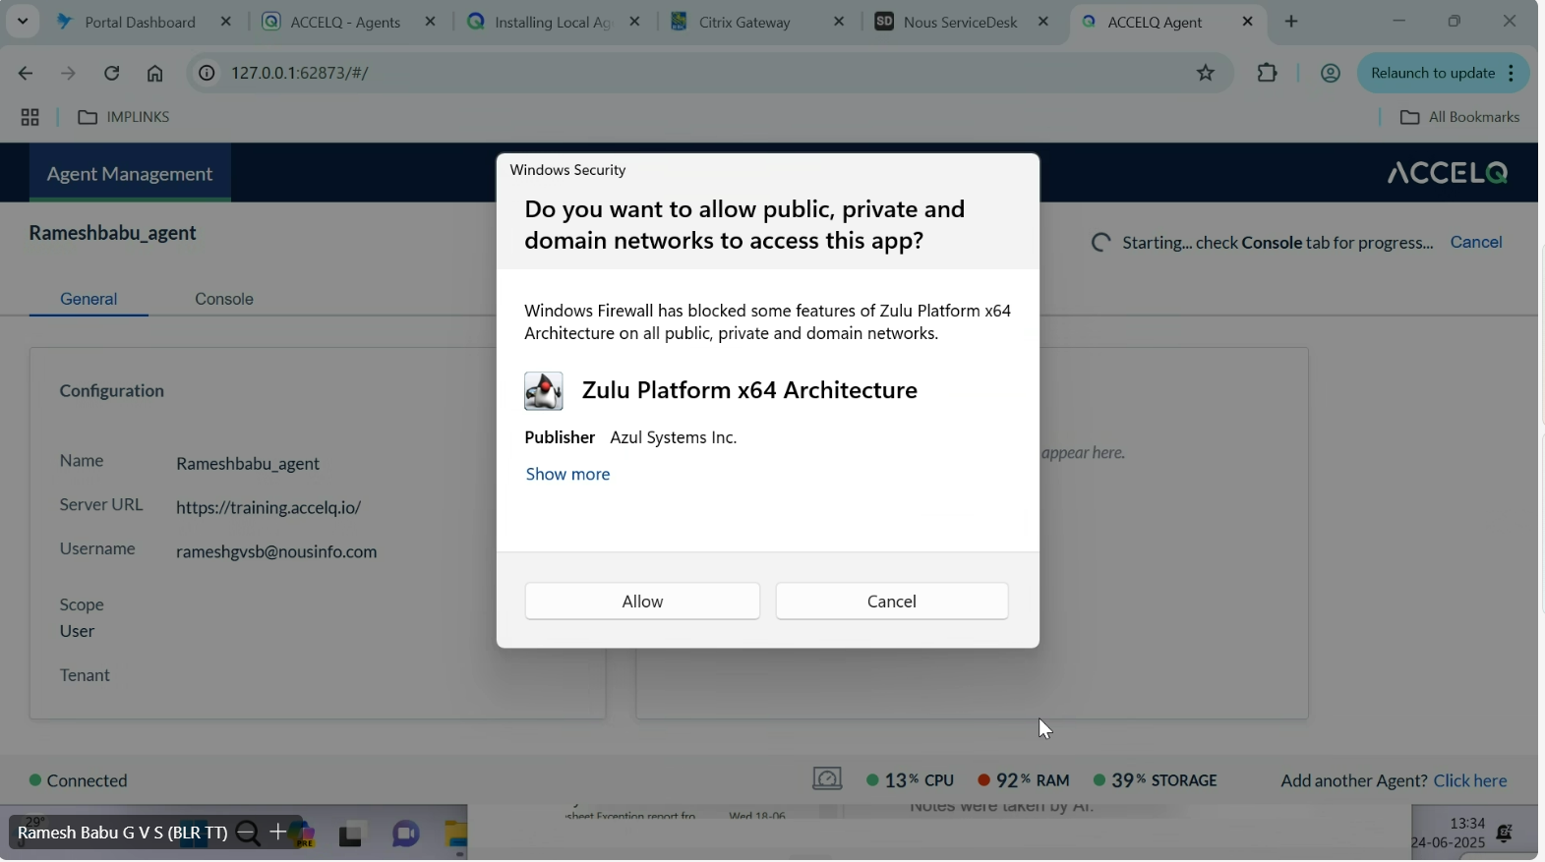

**Step 15:**

Following screen will display

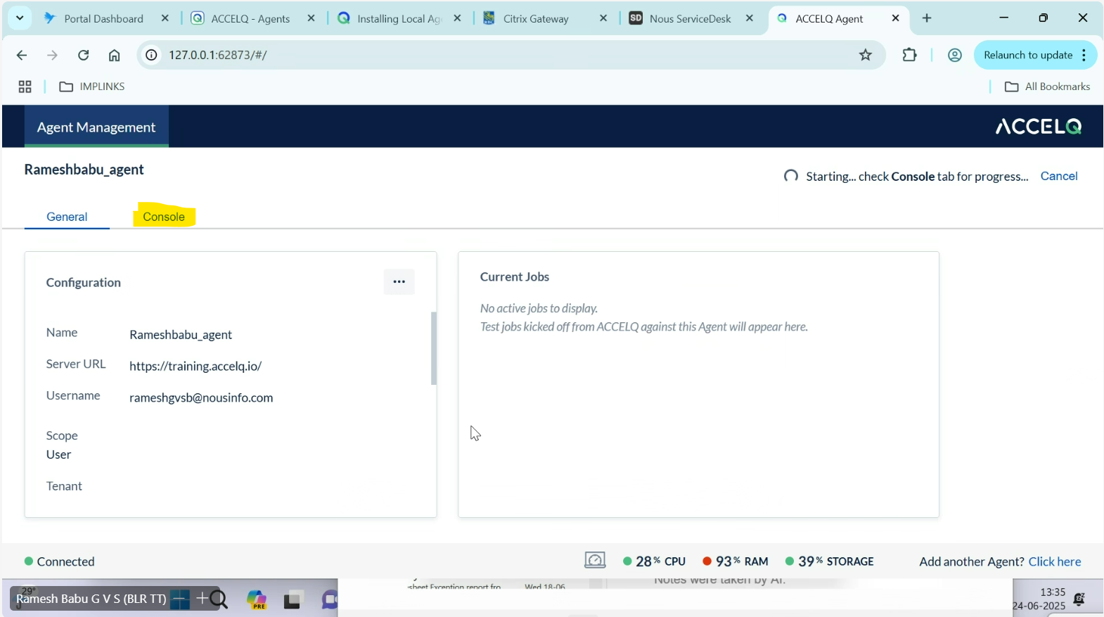

Click on “Console” Tab

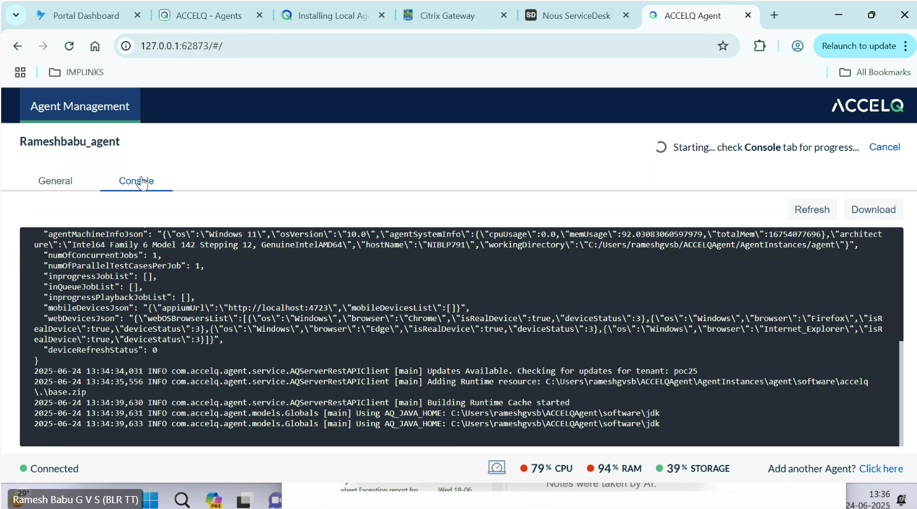

Wait until all the required jars and browser drivers are auto-download.

Setup Finished!!! – Agent ready to use.